安徽精能绿色能源有限公司

ATONE NEW ENERGY LIMITED
www.atoneenergy.comwww.atoneenergy.cn
2013.April./English Version

Solar Controller / Solar Inverter

The customer's demand is our greatest pursuit!

Enterprise profile：
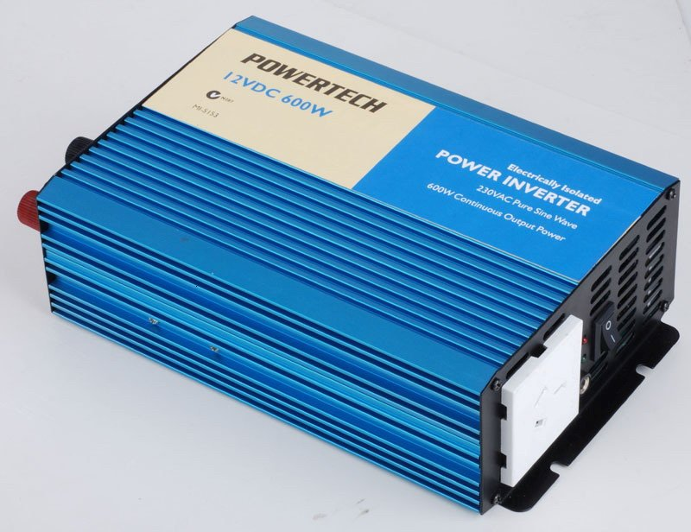
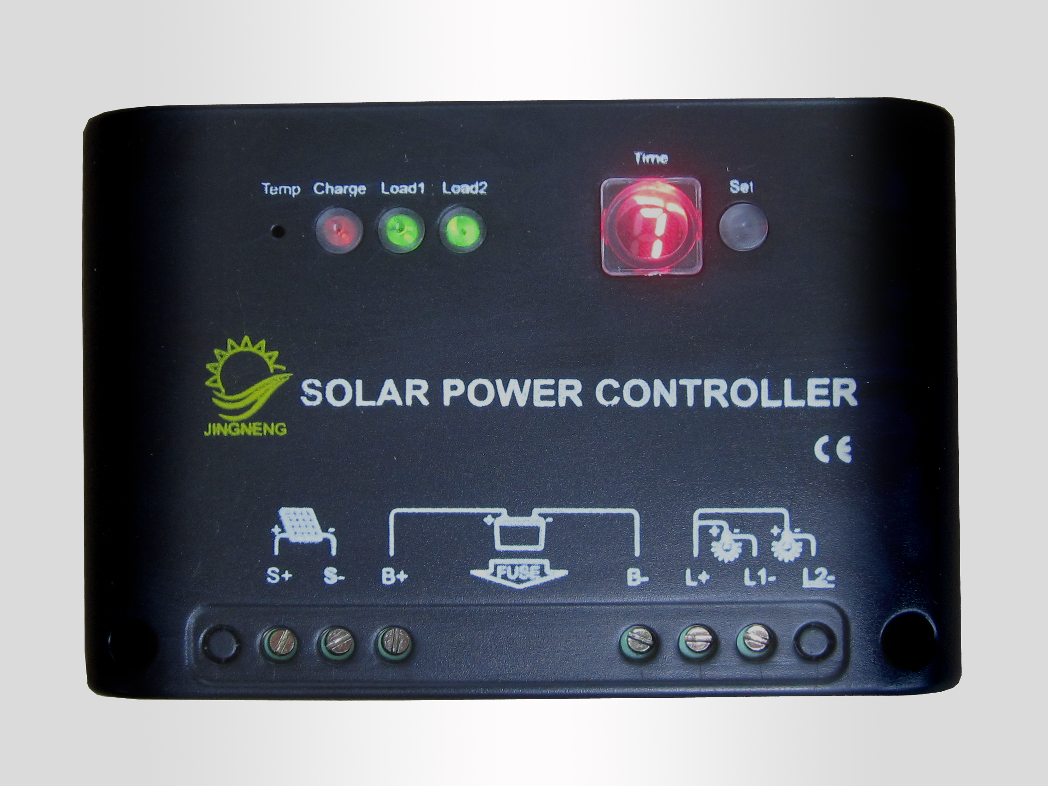
Atone New Energy Limited is a focus on solar energy, wind energy, and other renewable power source product research and development, production, sales and service of high and new technology enterprise. , the main products are photovoltaic
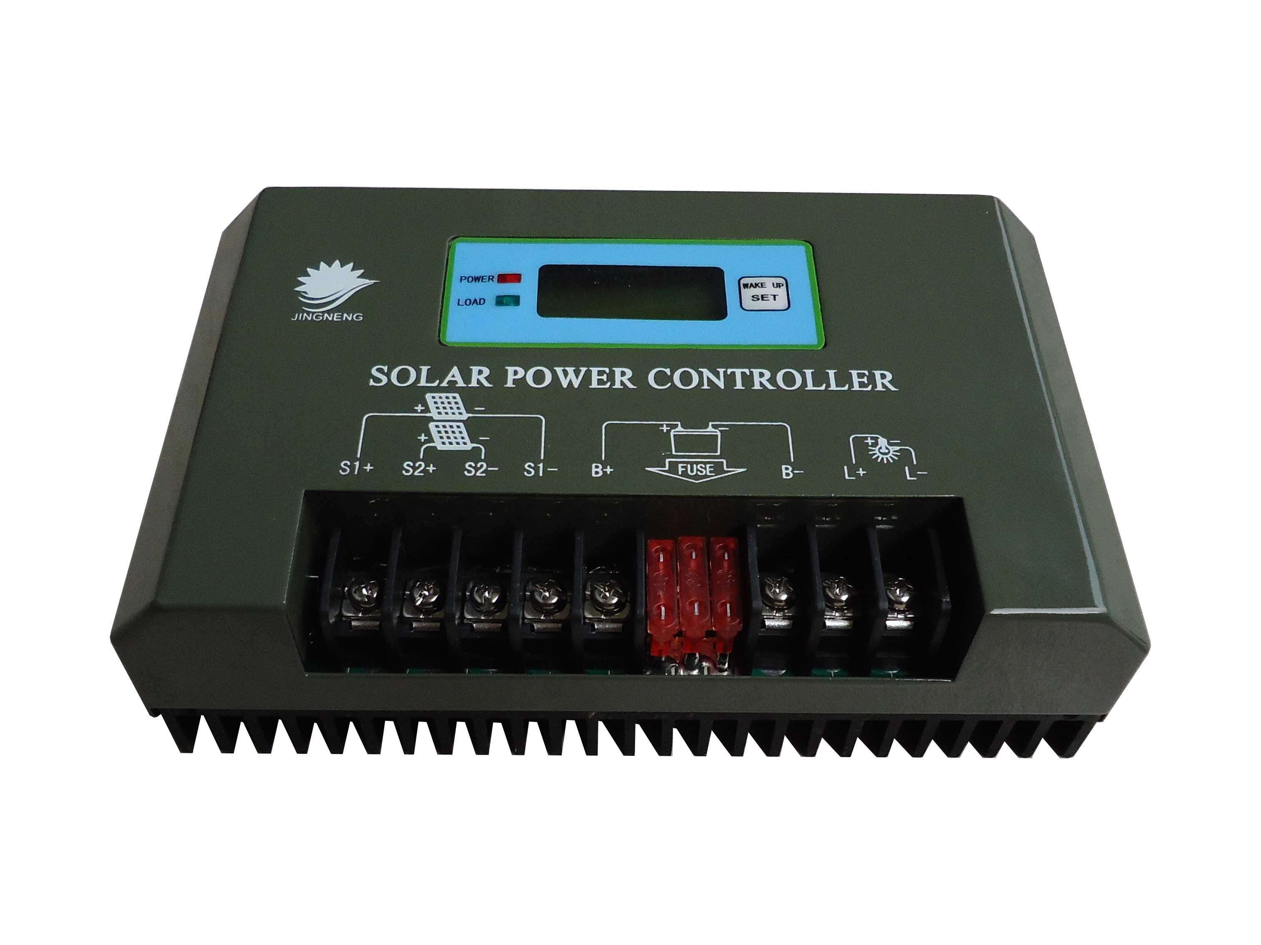
Inverter and solar controller, the wind solar hybrid controller, and offer solar power system, solar street lamps system design, production and installation, debugging and other services.

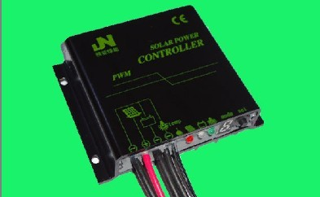
The company has always been to the development of the enterprise technological innovation as power supply, with a high quality talent team, with renewable energy research and development of the power supply industry rich experience and strong independent innovation ability,and participate in government number of significant project.
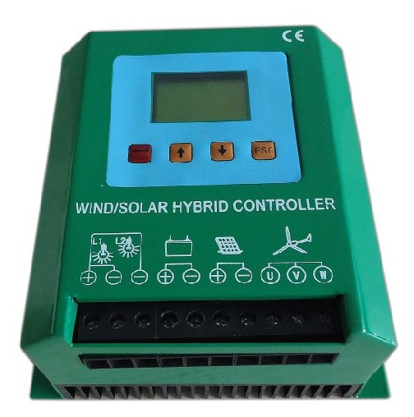
Enterprise purpose:
Companies adhering to the "integrity, innovation, dedication, and cooperation" spirit of enterprise, to provide quality system design, installation, technique modification solutions services, and continuously enhance customer and public satisfaction, strive to make the company more great contribution to society, global visibility of the new energy enterprise.

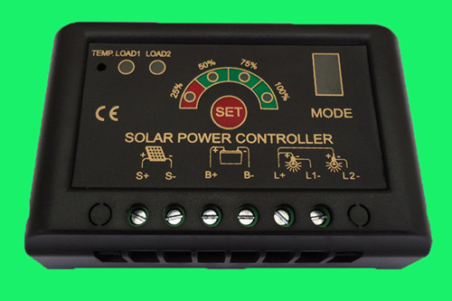

Catalogue

Catalogue .............................................................................................................. 1

★ Wind/solar hybrid controller series................................................................. 2

1. JW high-grade series wind solar hybrid controller.......................................... 3

2. Economic wind solar hybrid controller............................................................. 6

3.JN-WD High-end type wind solar hybrid controller..........................................

★ Solar controller................................................................................................ 7
- JC (5 A / 10 A) series solar controller .............................................................. 1
- JN-W（5A—10A）waterproof solar controller................................................ 2
- JN-WS Solar Waterproof-Constant Current Integrated Machine Controller..... 4
- JW Series Solar Waterproof-Electricity Hybrid Controller................................ 5
- JW Series Solar Electricity Hybrid Controller................................................... 6

6.. JN-T(20A-30A) series street light controller .................................................... 7

7. JC (30 A / 50 A) series controller....................................................................... 8

8. JN-S(5A-20A) series solar controller............................................................... 10

9. JC (100 A / 200 A) series high power solar controller...................................... 11

★ Solar power system and the street lamp system ............................................. 12

1. Solar power system ........................................................................................... 12

2. Solar street lamps system .................................................................................. 13

3. Wind solar hybrid street lamp system ............................................................... 14

4. Solar garden light system .................................................................................. 15

5. Solar lawn lamp system .................................................................................... 15

★ Inverter series .................................................................................................. 16

AN-H series high frequency sine wave inverter................................................ 16

1 AN-H300 series high frequency sine wave inverter ......................................... 17

2. AN-H500 series high frequency sine wave inverter............................................ 18

3. AN-H600 series high frequency sine wave inverter ........................................... 19

4. AN-H800 series high frequency sine wave inverter ........................................... 20

5. AN-H1000 series sine-wave inversion ............................................................... 21

6. AN-H1500 series high frequency sine wave inverter ......................................... 22

7. AN-H2000series high frequency sine wave inverter........................................... 23

8. AN-H2500series high frequency sine wave inverter........................................... 24

9. AN-H3000 series high frequency sine wave inverter ......................................... 25

10. AN-H4000 series high frequency sine wave inverter ....................................... 26

11. AN-H5000 series high frequency sine wave inverter ....................................... 27

12. AN-H6000 series high frequency sine wave inverter ....................................... 28

The company addresses and contact way: ................................................................ 29

★ Wind solar hybrid controller series
Wind solar hybrid controller make full use of green clean energy, zero emissions, zero pollution, zero power consumption etc, and the products are widely used in the remote area with no electric power communication stations, radio and television, the ships, the family uses electricity, etc.
AW series controller can adapt to the hybrid scenery is very bad working environment, use electronic brake and electronic unloading, and other functions, solve the output of the wind power generator with the wind change and wide fluctuations problem, prevent to open load fan windmills accidents. Comprehensive consideration of the solar and wind power generation characteristics of different,the optimum combination of the system and the operation.

Product features:
1) Intelligent design, simple structure, control powerful, stable performance, safety and reliability of the products.
2) Should choose MPPT fan charging ways, charging efficiency than ordinary PWM way more superior
3) booster charge function, solve the charging efficiency, low because of fan speed low of difficult problems
4) Choose a big size LCD display, users all parameters directly visible
A human nature of the key operation, all of the parameters according to the request of users can adjust for customers in various environment in use
5) Choose a PWM stepless uninstall way.
6) Should the output state has a variety of functions, often power/half power/in different period of customization features, etc
7) liquid crystal display battery charging electric current and voltage
8) utility the complementary function, uninterrupted soft handoff, guarantee load to continue to work. (this function should be customized)
9) digital intelligent control.
◆perfect protection function:

Protection function
Protection function | Illustrate | note
Solar counter- attack | in the night and filling bad light, the battery voltage may be higher voltage across the solar array. The controller with a counter-attack charging road, in order to prevent the battery of solar cell produce reverse filling.
Battery reverse connect battery protection | at the battery, the controller does not work, no display. | Properly connected to battery  anode can be normal operation
Open after long-term use battery protection | storage battery may happen to open or contact undesirable. This controller in the battery will protect the equipment itself after open without damage. | Regular inspection line connectivity
Overvoltage, wind speed and overload protection | in the wind or overvoltage state, the controller will automatically activated brake function to protect the fan and batteries. In an overload situation controller cut off the circuit automatically. | Circuit can be used maintenance can restore the resistance
- AW series Booster type wind solar hybrid controller(MPPT charge)
1). Product picture, wiring picture
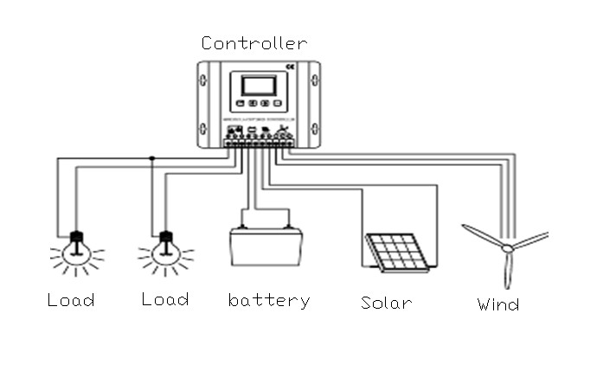

2). Technical parameters :
Model |  | AW1230 | AW1240 | AW2430 | AW2440 | AW2450 | AW2460 | AW2480
Rated voltage |  | 12V | 12V | 24V | 24V | 24V | 24V | 24V
Component power |  | 200W | 200W | 150W | 150W | 250W | 300W | 400W
Power of fan |  | 300W | 400W | 300W | 400W | 500W | 600W | 800W
charging | charging | 30A | 35A | 20A | 20A | 23A | 37.5A | 50A
charging | Even charge protection | 14.4V±1% |  | 28.8V±1%
charging | floating Charge | 13.8V±1% |  | 27.6V±1%
charging | Even charge recover | 13.2V±1% |  | 26.4V±1%
charging | Temperature Compensation | -24mV/℃ |  | -48mV/℃
Over Discharge | Shut off (DC) | 10.8V±1% |  | 21.8V±1%
Over Discharge | Resume (DC) | 12.3V±1% |  | 24.6V±1%
Over Voltage | Shut off (DC) | 16V±1% |  | 32V±1%
Over Voltage | Resume (DC) | 15V±1% |  | 30V±1%
No-load Current |  | ≤0.1A |  | ≤0.1A
Voltage drop (DC) |  | ≤0.5V
Control mode |  | Fan MPPT charge function, PWM uninstall function, PWM over-current limiting
Boost charge |  | Flexible independent step-up circuit (optional)
Display |  | LCD
Show parameters |  | voltage、charge current，battery volumetric
Protected type |  | Lightning protection, solar cells, anti-anti-charge protection, battery open-circuit protection, battery reversal protection, over speed and over-voltage soft automatic brake protection, overload protection.
Heat emanation way |  | Radiator
Working Temperature |  | -25℃~+55℃
Height |  | ≤5500m(2000m above the need to reduce power use)
Environment humidity |  | 0~90%，No condensation
Net Weight |  | 2.20KG
Size(L*W*H) |  | 164×181×100(MM)

2.ANW series Economic type wind solar hybrid controller(PWM charge)

1).Product picture

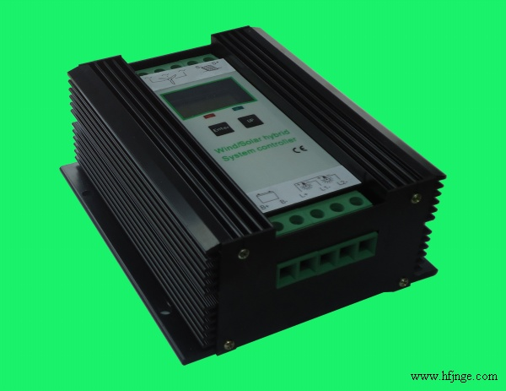

2).Technical parameter

Model |  | ANW  1230 | ANW  1240 | ANW  2430 | ANW  2440 | ANW  2440 | ANW  2450 | ANW  2460 | ANW  2480
System rated voltage |  | 12V | 12V | 24V
Photovoltaic module power |  | 200W | 200W | 150W | 250W | 300W | 250W | 300W | 400W
Wind power generator power |  | 300W | 400W | 300W | 400W | 400W | 500W | 600W | 800W
Charging | Charging | 30A | 30A | 20A | 23A | 37.5A | 23A | 37.5A | 50A
Charging | Are filling protection | 14.4V±1% |  | 28.8V±1%
Charging | Float filling | 13.8V±1% |  | 27.6V±1%
Charging | Are filling recovery | 13.2V±1% |  | 26.4V±1%
Charging | Temperature compensation | -24mV/℃ |  | -48mV/℃
Discharge | Disconnect (dc) | 10.8V±1% |  | 21.8V±1%
Discharge | Recovery (dc) | 12.3V±1% |  | 24.6V±1%
Over- voltage | Cut off (dc) | 16V±1% |  | 32V±1%
Over- voltage | Recovery (dc) | 15V±1% |  | 30V±1%
Idle current (dc) |  | ≤0.1A
Voltage drop (dc) |  | ≤0.5V
Control mode |  | Fan MPPT charge function, PWM unload function, PWM flow current limiting function
Booster charging |  | Flexible independent booster circuit (optional)
Display parameters |  | Voltage, charging electric current, storage battery power
Showing the way |  | LCD
Protection type |  | Lightning protection, Solar reverse charge protection, battery open-circuit protection, battery reverse protection, over wind speed and over-voltage soft automatic brake protection, overload protection etc.
Cooling mode |  | Radiator
Environment temperature |  | -25℃~+55℃
Use altitude |  | ≤5500 m (2000 m above the need to reduce power use)
Environment humidity |  | 0~90%, not knot de
Weight |  | 1.15KG
Shape dimension |  | 165*140*64mm

- AN-WD High-end type wind solar hybrid controller(Built-in unloading box and PWM charge)

1).Product picture
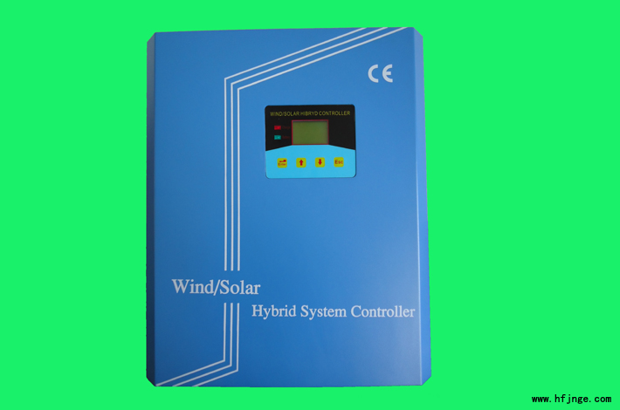
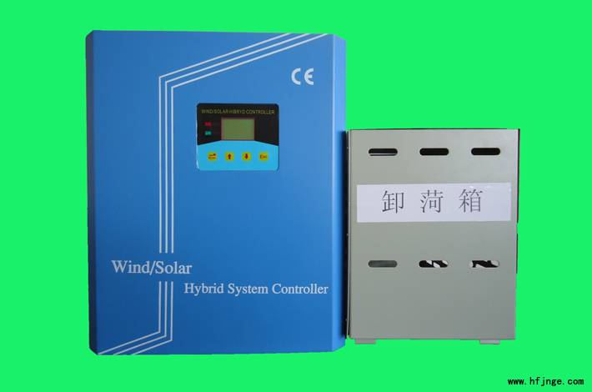

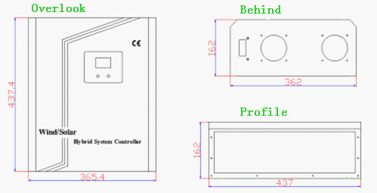

2).Technical parameter
Model No. | AN-WD24 | AN-WD48 | AN-WD96 | AN-WD120 | AN-WD240
Wind turbine power | 1kw | 1kw  2kw  3kw  5kw | 2kw  3kw  5kw  10kw | 3kw  5kw  10kw | 3kw  5kw  10kw
Solar max power | 300w | 300w  600w  1000w  1500w | 600w  1000w  1500w  3000w | 1000w  1500w  3000w | 1000w  1500w  3000w
Over-charge voltage | 28.8v | 57.6v | 116v | 144v | 288v
Over-charge recovery voltage | 26v | 56v | 110v | 138v | 264v
Method of control | PWM
Free-load lost power | ≤6mA
Voltage lost on charging | ≤0.26V
Voltage lost on discharge | ≤0.15V
Environment temperature | -25℃ - +55℃
Shape Dimension | 440mm×366mm×166mm
Dump-load Dimension | 400mm×230mm×290mm
Net Weight | 8KG
Cooling Way | Cooling Fan

★ Solar controller
Solar street lamps controller is a through the microprocessor control and display the intelligent charging and discharging controller, the high quality, low loss, the life is long components, to ensure the reliable performance, to make the street lamp system can long normal work, reduce the system maintenance cost, especially the maintenance of batteries to significantly reduce the cost.
AC series solar street lamps controller can adapt to bad work environment, can provide two loaded access by setting the function can be key to set up and free time set up light work time, according to the strength of the light automatic open or closed load, and can be used in low pressure LED, sodium lamp, energy-saving lamp, metal halide lamp, street lamp, garden lamp series of lighting system.
Product feature:
1.MCU control,achieve charge and discharge intelligent control.
2.With perfect memory function, the controller can according to the interrupt mode of work in front,when the controller re-energized
3.Time and light control, you can set any value at ten minutes 15 hours, realization of timing accuracy fine.
4.It has perfect battery over charge and discharge protection function.
5.Battery open-circuit,over voltage,output short-circuits protection function.
6.Bollard cell converse connection,converse charge protection at night.
7.Under voltage protection,shock protection,low no-load wasting.
8.Temperature compensation.

1. AC（5A/10A）series solar controller
1). Product picture
2). Technical parameters
The product model | Discharge parameters (V) |  | Pressure parameters (V) |  | Charging parameter (V) |  | Way to work | State instructions | No-load  Current  (A)
 | Discharge protection | Discharge recovery | Over-  voltage protection | Over-  voltage reply | Are filling protection | Are filling recovery
AC1205LT | 11.1V±1% | 13.2V±1% | 16.5V±1% | 15.0V±1% | 14.4V±1%1 | 13.3V±1% | Double time  Electric + control | Digital tube | ≤0.01
AC1210LT | 11.1V±1% | 13.2V±1% | 16.5V±1% | 15.0V±1% | 14.4V±1% | 13.3V±1% | Double time  Electric + control | Digital tube | ≤0.01
AC2405LT | 22.2V±1% | 26.4V±1% | 33.0V±1% | 30.0V±1% | 28.8V±1% | 26.6V±1% | Double time  Electric + control | Digital tube | ≤0.01
AC2410LT | 22.2V±1% | 26.4V±1% | 33.0V±1% | 30.0V±1% | 28.8V±1% | 26.6V±1% | Double time  Electric + control | Digital tube | ≤0.01

2. AN-W（5A—15A）waterproof solar controller
1).Product picture, Dimension figure:
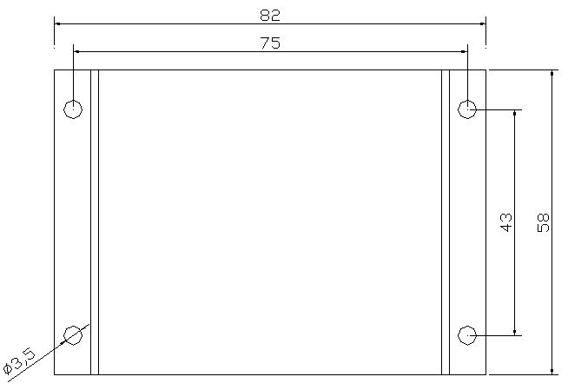
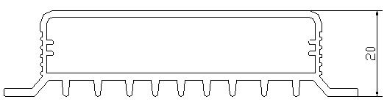

2). Product features
(1). IP68 waterproof level, aluminum shell design, can effectively prevent all kinds of corrosion.
(2). 12 V / 24 V voltage to be automatic identification system.
(3). LED digital display and waterproof the key operate, use simple and quick.
(4). Improved tasting charging algorithm, every week for a balanced battery charging, effective
Prevent battery not balanced and curing phenomenon, improve battery service life.
(5). Five kind of load mode, convenient use in all kinds of street lamp and monitoring equipment.
(6). External temperature sensor, and has high precision temperature compensation.
(7) Parameters set off electricity save function without repeating Settings, convenience and fast.
(8) All kinds of state instructions.
(9). With the charger, discharge, overload protection and electronic short circuit protection and meter protector against fraud protection.
(10) TVS lightning protection.

System voltage | 12V/24V Auto
System current | 5A/10A/15A
No-load loss | < 5mA
Solar input voltage | < 55V
Over-voltage protection | 16.5V；×2/24V
Balance charge voltage | 14.6V；× 2/24 V (25 ℃), maintain time: 1 hour
Ascension recharging voltage | 14.4V；2/24 V (25 ℃), maintain time: two hours
Float charging pressure | 13.8V；×2/24V （25℃）
Charging to return to voltage | 13.2V；×2/24V （25℃）
Discharge to return to voltage | 12.5V；×2/24V
Discharge protection | 10.8V；×2/24V
Temperature compensation | -4.0mv/℃/2V；
Electric voltage | Electric drive 7 V, electric close 2 V
Electric tell time | 1min
Overload, short circuit protection | 1.25 times rated current 3 minutes to be automatic recovery;  1.5 times rated current 5 minutes to be automatic recovery;  ≥2 times rated current frequency, short circuit protection, could not be restored, need to manually check the recovery
Working temperature | -35 ℃ to + 65 ℃;
Protection grade | IP68
weight | 0.15Kg
size | 65 x 67 x 18 (mm) (long x width × high)

3. AN-WS Solar Waterproof-Constant Current Integrated Machine Controller
1).Product picture, Dimension figure:

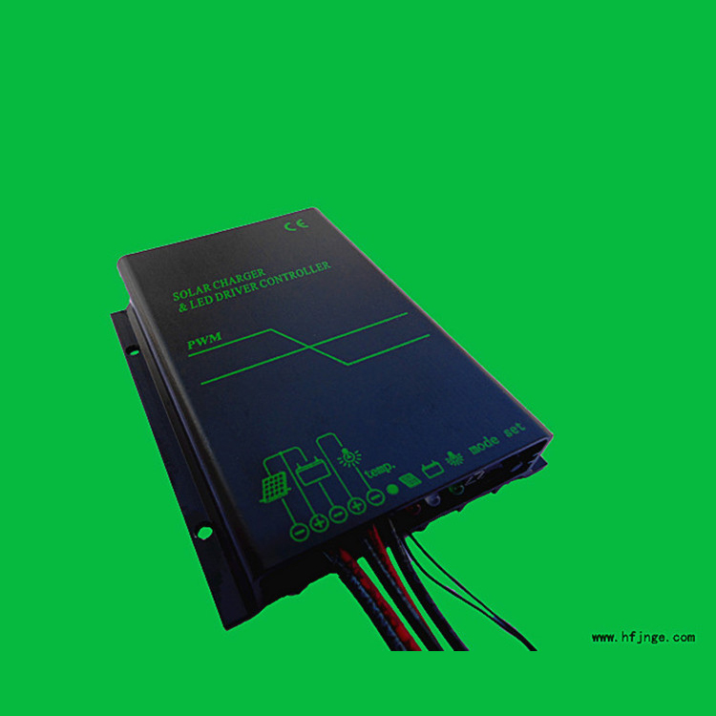
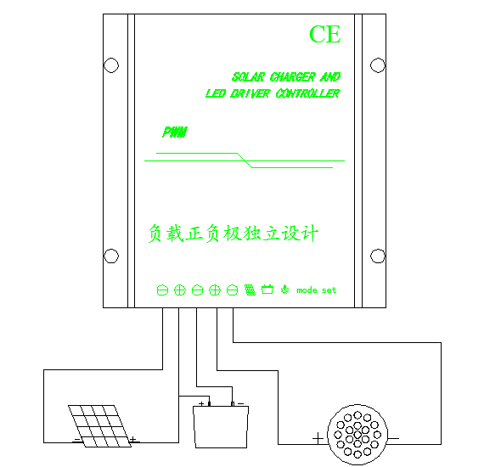

2). Technical parameters
System voltage | 12V/24V Auto
System current | 5A/10A
No-load consumption | < 5mA
Solar input voltage | < 55V
Over voltage protection | 16.5V; *2/24V
Equalizing charge voltage | 14.6V; *2/24V(25℃), hold time：1 hour
Float charge voltage | 13.8V; *2/24V (25℃)
Charge return voltage | 13.2V; *2/24V (25℃)
Over discharge voltage | 12.5V; *2/24V
Over discharge protection | 10.8V; *2/24V
Light control voltage | Light control OPEN 2V; *2/24V, Light control CLOSE 7V; *2/24V
Working temperature | -35℃-------+65℃;
Protection level | IP68
Net weight | 0.15Kg
Size | 102*81*19.6(mm)（L×W×H）

- AW Series Solar Waterproof-Electricity Hybrid Controller
1).Product picture, Dimension figure:

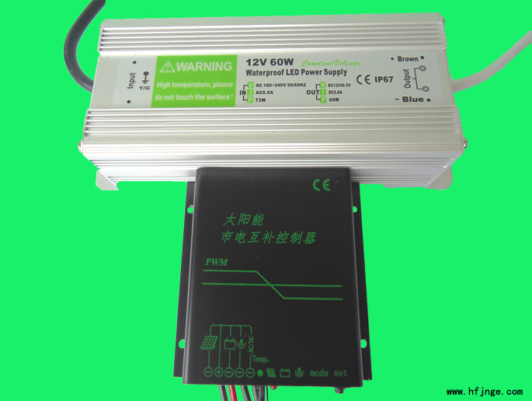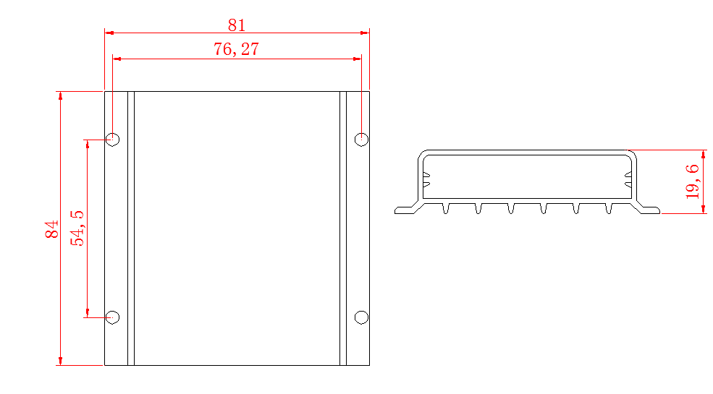
2). Technical parameters

System voltage | 12V/24V Auto
System current | 5A/10A
No-load consumption | < 5mA
Solar input voltage | < 55V
Over voltage protection | 16.5V; *2/24V
Equalizing charge voltage | 14.6V; *2/24V(25℃), hold time: 1 hour
Improve charging voltage | 14.6V; *2/24V(25℃), hold time: 1 hour
Float charge voltage | 13.8V；*2/24V (25℃)
Charge return voltage | 13.2V；*2/24V (25℃)
Over discharge voltage | 12.5V; *2/24V
Over discharge protection | 10.8V; *2/24V
Light control voltage | Light control OPEN 2V; *2/24V, Light control CLOSE 7V; *2/24V
Working temperature | -35℃-------+65℃；
Protection level | IP68
Switch voltage | 11.0; *2/24V
Net weight | 0.15Kg
Size | 84×81×18(mm)（L×W×H）

- AW Series Solar Electricity Hybrid Controller
1). Product picture，dimension figure

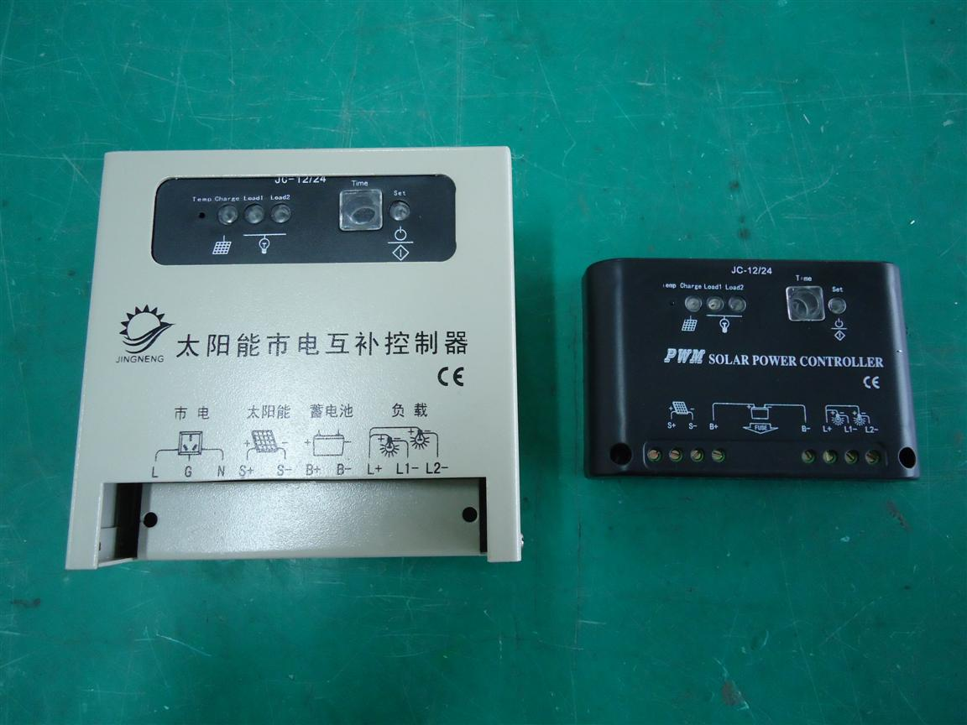
2). Technical parameters
Model |  |  | AC2405 |  | AC2410 | AC1205 | AC1210
Rated voltage |  |  | 24V |  |  | 12V
Max input power |  |  | 120W | 240W |  | 60W | 120W
current | Discharge |  | 5A | 10A |  | 5A | 10A
current | Charge |  | 5A | 10A |  | 5A | 10A
Charge | Average charge |  | 28.8V±1% |  |  | 14.4V±1%
Charge | Recover |  | 26.6V±1% |  |  | 13.3V±1%
Charge | Floating |  | (27.0V-27.6V)±1% |  |  | (13.5V-13.8V)±1%
Charge | Temperature  Compensator |  | -36mV/℃ |  |  | -18mV/℃
Start voltage |  |  | 24.6V±1% |  |  | 12.3±1%
Over discharge |  | Switching off | 22.2V±1% |  |  | 11.1V±1%
 |  | Recover | 26.4V±1% |  |  | 13.2V±1%
Over voltage |  | Switching off | 33V±1% |  |  | 16.5V±1%
 |  | Switching off | 30V±1% |  |  | 15V±1%
Non-load current |  |  | ≤10mA |  |  | ≤10mA
Max open circuit voltage |  |  | 50V |  |  | 25V
Voltage drop |  |  | Input ≤0.7V |  |  | Input ≤0.6V
 |  |  | Output ≤0.3V |  |  | Output ≤0.3V
Display |  |  | LED
Operating temperature |  |  | -25℃~+55℃
Using altitude |  |  | ≤5500m(above 2000m need reduced the power )
Product size and weight |  |  | 120mmx80mmx25mm 0.13Kg

6.AN-T(20A-30A)series street light controller
1). Product picture，dimension figure
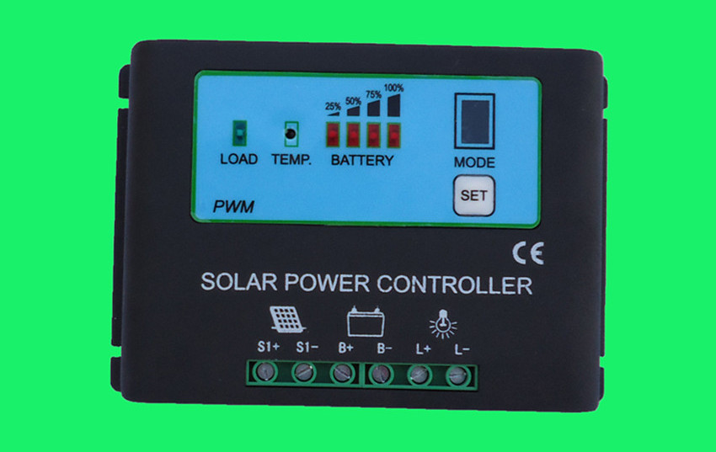
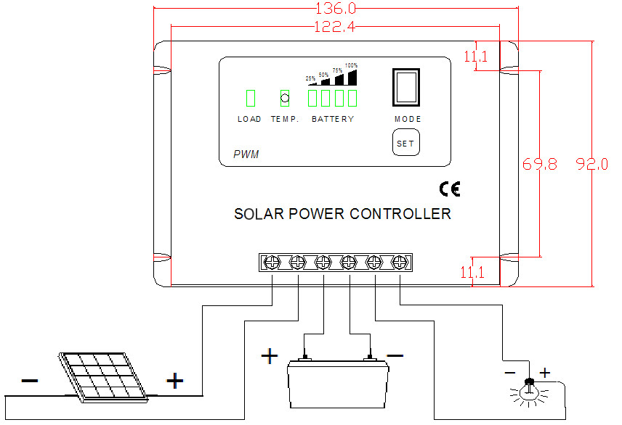
2).Technical parameters
Rated voltage | 12 v, 24 v auto
Strong charging pressure | 14.8V/29.6V
Equilibrium charging | 14.5V/29V
Float charging pressure | 13.7V/27.4V
Under voltage protection | 10.8V/21.6
Under recover voltage | 13V/26V
Maximum charging current | 30A
Maximum load current | 30A
Over load protection | 3 s recover 1.2 times, 10 s recover 1.5 times , more than two times need manual recover
Maximum wire diameter | 4mm²
Working temperature | -40-60℃
Weight (gross) | 0.3KG
Product size | 136*92*31mm
Protection level | IP56

7. AC(30A/50A) series controller
1). Product picture
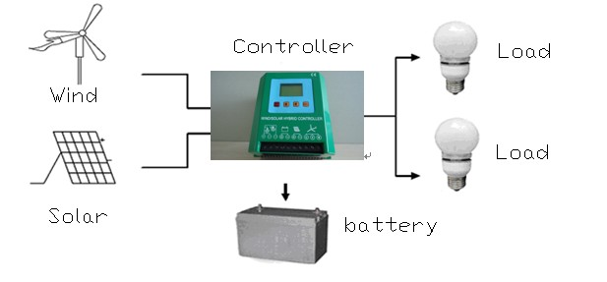
- .Technical parameters:

The product model | Discharge parameters (V) |  | Pressure parameters (V) |  | Charging parameter (V) |  | Way to work | State instructions | Idle current (A)
The product model | Discharge protection | Discharge recovery | Over- voltage protection | Over- voltage reply | Are filling protection | Are filling recovery | Way to work | State instructions | Idle current (A)
AC1230LT | 11.1V±1% | 13.2V±1% | 16.5V±1% | 15.0V±1% | 14.4V±1% | 13.3V±1% | Double time  Electric + control | LCD | ≤0.01
AC1250LT | 11.1V±1% | 13.2V±1% | 16.5V±1% | 15.0V±1% | 14.4V±1% | 13.3V±1% | Double time  Electric + control | LCD | ≤0.01
AC2430LT | 22.2V±1% | 26.4V±1% | 33.0V±1% | 30.0V±1% | 28.8V±1% | 26.6V±1% | Double time  Electric + control | LCD | ≤0.01
AC2450LT | 22.2V±1% | 26.4V±1% | 33.0V±1% | 30.0V±1% | 28.8V±1% | 26.6V±1% | Double time  Electric + control | LCD | ≤0.01
AC4830LT | 44.4V±1% | 52.8V±1% | 66.0V±1% | 60.0V±1% | 57.6V±1% | 53.2V±1% | Double time  Electric + control | LCD | ≤0.01
AC4850LT | 44.4V±1% | 52.8V±1% | 66.0V±1% | 60.0V±1% | 57.6V±1% | 53.2V±1% | Double time  Electric + control | LCD | ≤0.01

8. New Style AN-S(5A-20A) 12V/24V Auto Solar Controller

1). Product picture，dimension figure

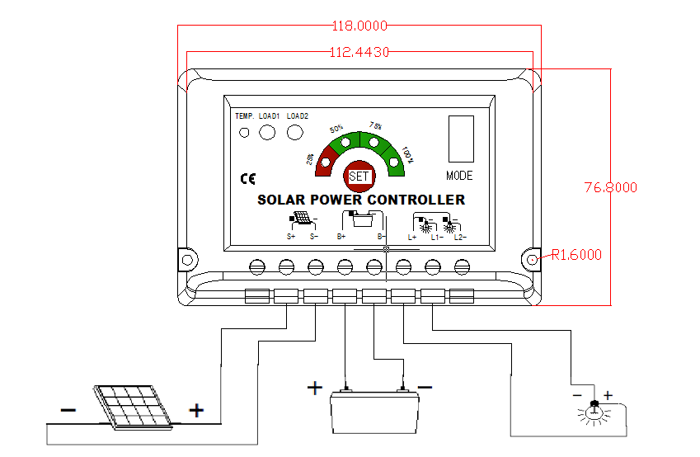
2. Technology parameters:
Rated voltage | 12 v, 24 v auto
Strong charging pressure | 14.8V/29.6V
Equilibrium charging | 14.5V/29V
Float charging pressure | 13.7V/27.4V
Under voltage protection | 10.8V/21.6
Under recover voltage | 13V/26V
Maximum charging current | 20A
Maximum load current | 20A
Over load protection | 3 s recover 1.2 times, 10 s recover 1.5 times , more than two times need manual recover
Maximum wire diameter | 4mm²
Working temperature | -40-60℃
Weight (gross) | 0.15KG
Product size | 120*78*35mm
Protection level | IP56

9. AC(100A/200A) series high power solar controller

1)．Product picture

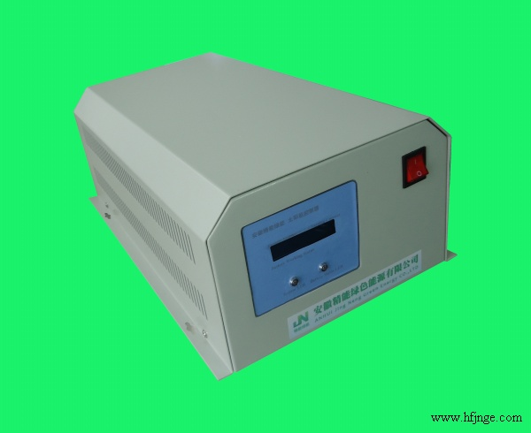

2. Technical parameters:
model | AND24V-100A | AND48V-100A | AND96V-100A | AND120V-100A
Solar energy input current rating | 100A
Battery rated voltage | 24V | 48V | 96V | 120V
Owe pressure (V) | 21 | 42 | 84 | 105
Owe pressure recovery (V) | 24 | 48 | 96 | 120
Over-voltage (V) | 29.4 | 58.8 | 117.6 | 147
Pressure recovery (V) | 28 | 56 | 112 | 140
Float charging pressure (V) | 27 | 54 | 108 | 135
Static loss | ≦0.09
Showing the way | Liquid crystal display
Display parameters | Battery voltage, charging electric current, charging
Way to work | Continuous
Use of the environment | Temperature-10-+ 40 ℃ ℃, relative humidity is not more than 85%
Size  (long * wide* high) | 41*25*16（cm）
Net weight (KG) | 6.8KG
Gross (KG) | 7.1KG

★ Solar power system and the street lamp system
1. Solar power generation system
Product example:
solar cell module:1600W, free maintenance battery:800AH, the pure single inverter：3000W,charging controller：50A 。
Equipment can use appliances as well as the time is as follows:

Design load  electrical name | specifications | Power consumption power | number | Day of working time | Power consumption
Lighting | Energy-saving lamps | 11W | 8 | 6 | 528Wh
Computer | Liquid crystal display | 100W | 2 | 5 | 1000 Wh
Printer | laser | 250W | 1 | 1 | 250 Wh
Fax machine | inkjet | 150W | 1 | 1 | 150 Wh
Refrigerators | 150L | 100W | 1 | 24 | 800 Wh
Washing machine |  | 300W | 1 | 0.5 | 150 Wh
VCD Satellite TV receiver/VCD |  | 25W | 1 | 6 | 150 Wh
Color TV | 21 inches | 95W | 1 | 6 | 570 Wh
Pump |  | 400W | 1 | 1 | 400 Wh
Total |  | 1431W |  |  | 3998 Wh

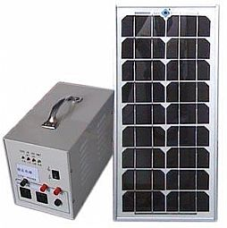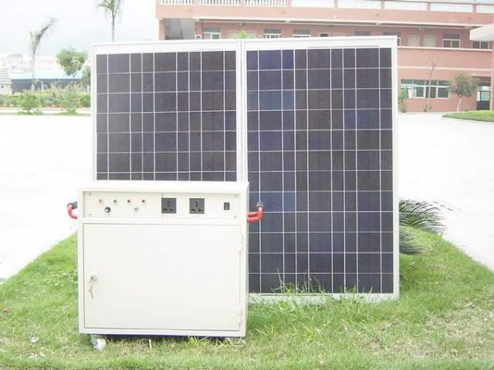

- Solar street lamp system

Product example:

35W solar low voltage sodium lamp system configuration
Parts name | specifications | Unit | Quantity | Note
Solar panels | 17.6V/120W | pc | 1 | Single/crystal
Solar controller | 12V/10A | set | 1 | Electric+control
Battery | 12V/120AH | pc | 1 | Lead -acid/ colloid
LED light | 12V/35W | set | 1 | Orange
Street lamps |  | pc | 1 | Casting aluminum
The lamp pole and accessories |  | set | 1 | Hot dip galvanized coating
Above the system configuration can use 3 consecutive rainy days.
According to different areas and different climate need to adjust.

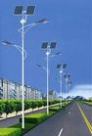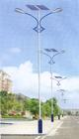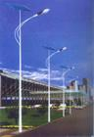
JNL-001 JNL-002 JNL-003
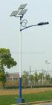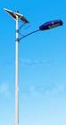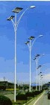
JNL-004 JNL-005 JNL-006

3．Wind/solar complementary street lamp system

Product example:
35W solar low voltage sodium lamp system configuration
Parts name | specifications | Unit | Quantity | Note
Solar panels | 17.6V/120W | pc | 1 | Single/crystal
Wind generator | 24V/300W | Set | 1 | Permanent magnetism generators
Solar controller | 12V/10A | Set | 1 | Electric+control
Battery | 12V/120AH | pc | 1 | Lead -acid/ colloid
LED light | 12V/35W | set | 1 | Orange
Street lamps |  | pc | 1 | Casting aluminum
The lamp pole and accessories |  | set | 1 | Hot dip galvanized coating
Above the system configuration can use continuously in 3 rainy days.
According to different areas and different climate need to adjust.

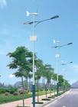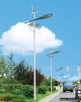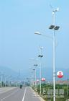
JNW-001 JNW-002 JNW-003
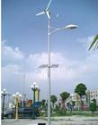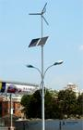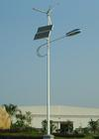
JNW-004 JNW-005 JNW-006

- Solar garden light system
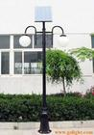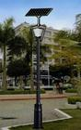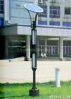
JNG-001 JNG-002 JNG-003 JNG-004
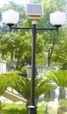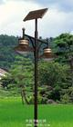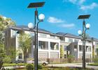
JNG-005 JNG-006 JNG-007 JNG-008

5.Solar lawn lamp system
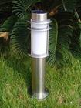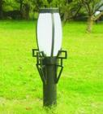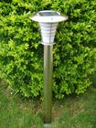
JNN-001 JNN-002 JNN-003 JNN-004
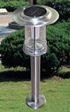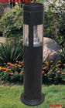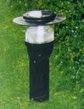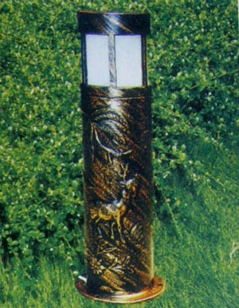

JNN-005 JNN-006 JNN-007 JNN-008

★Inverter series

AE-H series high frequency sine wave inverter

AE-H series intelligent pure sine wave with high frequency inverter power supply PWM control technology and high power mosfet or IGBT components, so that the work products, low noise, fast response time output waveform good, working voltage and frequency stability, reliability, etc. This product has the automation of high automation, stable performance, the function is all ready, perfect protection, simple operation and other characteristics, can 24 hours work unattended, applicability, practical strong, used in the remote area with no electric power communication stations, television broadcasts, the ships, the family of electricity.

Product features:

1) The use of advanced CPU single-chip microcomputer intelligent control technology double, high reliability, low failure rate of characteristics.
2) Pure sine wave output, with load capacity, wide application.
3) With perfect protection function (voltage protection, over-voltage protection, output short circuit protection, thermal protection, overload protection).
4) Cooling fan intelligent control, the cooling fan CPU control of the work of the state, greatly extend the service life of the fan, and saving energy efficiency.
5) Work little noise, high efficiency, the output of the perfect pure waveform, prolong the service life of electrical equipment.
6) Low voltage alarm function.

- AE-H300 High frequency pure sine wave inverter

1) Product picture:
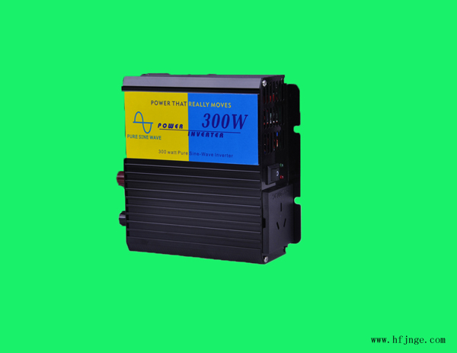

- Technical parameters:
OUTPUT | OUTPUT VOLT | 100/110/120/220/230/240VAC
OUTPUT | CONTINUOUS POWER | 300W
OUTPUT | SURGE POWER | 600W
OUTPUT | WAVEFORM | PURE SINE WAVE
OUTPUT | FREQUENCY | 50Hz/60Hz
OUTPUT | AC REGULATION | low & high 10%
OUTPUT | USB CHARGER | 5V
OUTPUT | LED INDICATOR | LED DISPLAY POWER & FAIL STATUS
INPUT | NO LOAD CURRENT DRAW | 0.2A～0.3A | 0.15A～0.2A | 0.1A～0.15A
INPUT | DC VOLTAGE | 10-15VDC | 20-30VDC | 40-61VDC
INPUT | VOLTAGE RANGE | 12VDC | 24VDC | 48VDC
INPUT | FUSE | 35A | 20A | 15A
PROTECTION | BATTERY LOW SHUTDOWN | ±10V
PROTECTION | OVER TEMPERATURE | ±70℃
PROTECTION | BATTERY LOW ALARM | ±10.5V
PROTECTION | OUTPUT SHORT | SHUT OFF OUTPUT VOLTAGE,RE-POWER ON TO RECOVER
PROTECTION | OVER LOAD | 120%
PROTECTION | OVER VOLTAGE | ±15V | ±30V | ±61V
OTHER | DIMENSION(L*W*H) | 150*130*52mm
OTHER | INNER BOX DIMENSION | 255*190*90mm
OTHER | CARTON DIMENSION | 550*430*340mm
OTHER | NET WEIGHT | 0.85±0.1KG
OTHER | GROSS WEIGHT | 16±1KG
OTHER | PACKING | 12PCS/CTN
- AE-H500 High frequency pure sine wave inverter

1) Product picture:
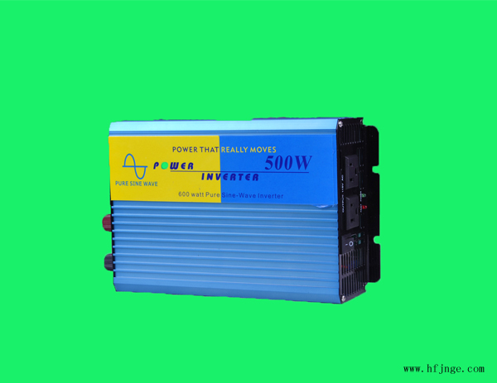

2)Technical parameters:
OUTPUT | OUTPUT VOLT | 100/110/120/220/230/240VAC
OUTPUT | CONTINUOUS POWER | 500W
OUTPUT | SURGE POWER | 1000W
OUTPUT | WAVEFORM | PURE SINE WAVE
OUTPUT | FREQUENCY | 50Hz/60Hz
OUTPUT | AC REGULATION | low & high 10%
OUTPUT | USB CHARGER | 5V
OUTPUT | LED INDICATOR | LED DISPLAY POWER & FAIL STATUS
INPUT | NO LOAD CURRENT DRAW | 0.2A～0.3A | 0.15A～0.2A | 0.1A～0.15A
INPUT | DC VOLTAGE | 10-15VDC | 20-30VDC | 40-61VDC
INPUT | VOLTAGE RANGE | 12VDC | 24VDC | 48VDC
INPUT | FUSE | 35A | 20A | 15A
PROTECTION | BATTERY LOW SHUTDOWN | ±10V
PROTECTION | OVER TEMPERATURE | ±70℃
PROTECTION | BATTERY LOW ALARM | ±10.5V
PROTECTION | OUTPUT SHORT | SHUT OFF OUTPUT VOLTAGE,RE-POWER ON TO RECOVER
PROTECTION | OVER LOAD | 120%
PROTECTION | OVER VOLTAGE | ±15V | ±30V | ±61V
OTHER | DIMENSION(L*W*H) | 210*150*70mm
OTHER | INNER BOX DIMENSION | 325*190*110mm
OTHER | CARTON DIMENSION | 430*350*440mm
OTHER | NET WEIGHT | 1.4±0.2KG
OTHER | GROSS WEIGHT | 14.5±1KG
OTHER | PACKING | 6PCS/CTN
- AE-H600 High frequency pure sine wave inverter

1) Product picture:
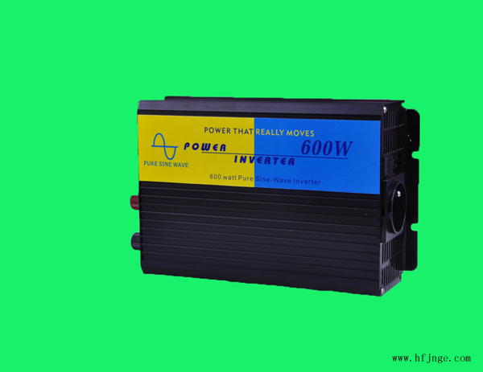

2)Technical parameters:
OUTPUT | OUTPUT VOLT | 100/110/120/220/230/240VAC
OUTPUT | CONTINUOUS POWER | 600W
OUTPUT | SURGE POWER | 1200W
OUTPUT | WAVEFORM | PURE SINE WAVE
OUTPUT | FREQUENCY | 50Hz/60Hz
OUTPUT | AC REGULATION | low & high 10%
OUTPUT | USB CHARGER | 5V
OUTPUT | LED INDICATOR | LED DISPLAY POWER & FAIL STATUS
INPUT | NO LOAD CURRENT DRAW | 0.2A～0.3A | 0.15A～0.2A | 0.1A～0.15A
INPUT | DC VOLTAGE | 10-15VDC | 20-30VDC | 40-61VDC
INPUT | VOLTAGE RANGE | 12VDC | 24VDC | 48VDC
INPUT | FUSE | 35A | 20A | 15A
PROTECTION | BATTERY LOW SHUTDOWN | ±10V
PROTECTION | OVER TEMPERATURE | ±70℃
PROTECTION | BATTERY LOW ALARM | ±10.5V
PROTECTION | OUTPUT SHORT | SHUT OFF OUTPUT VOLTAGE,RE-POWER ON TO RECOVER
PROTECTION | OVER LOAD | 120%
PROTECTION | OVER VOLTAGE | ±15V | ±30V | ±61V
OTHER | DIMENSION(L*W*H) | 210*150*70mm
OTHER | INNER BOX DIMENSION | 325*190*110mm
OTHER | CARTON DIMENSION | 430*350*440mm
OTHER | NET WEIGHT | 1.8±0.2KG
OTHER | GROSS WEIGHT | 14.6±1KG
OTHER | PACKING | 6PCS/CTN
- AE-H800 High frequency pure sine wave inverter
1) Product picture:
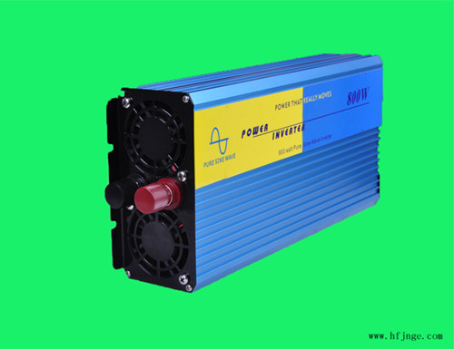

2)Technical parameters:
OUTPUT | OUTPUT VOLT | 100/110/120/220/230/240VAC
OUTPUT | CONTINUOUS POWER | 800W
OUTPUT | SURGE POWER | 1600W
OUTPUT | WAVEFORM | PURE SINE WAVE
OUTPUT | FREQUENCY | 50Hz/60Hz
OUTPUT | AC REGULATION | low & high 10%
OUTPUT | USB CHARGER | 5V
OUTPUT | LED INDICATOR | LED DISPLAY POWER & FAIL STATUS
INPUT | NO LOAD CURRENT DRAW | 0.2A～0.3A | 0.15A～0.2A | 0.1A～0.15A
INPUT | DC VOLTAGE | 10-15VDC | 20-30VDC | 40-61VDC
INPUT | VOLTAGE RANGE | 12VDC | 24VDC | 48VDC
INPUT | FUSE | 35A | 20A | 15A
PROTECTION | BATTERY LOW SHUTDOWN | ±10V
PROTECTION | OVER TEMPERATURE | ±70℃
PROTECTION | BATTERY LOW ALARM | ±10.5V
PROTECTION | OUTPUT SHORT | SHUT OFF OUTPUT VOLTAGE,RE-POWER ON TO RECOVER
PROTECTION | OVER LOAD | 120%
PROTECTION | OVER VOLTAGE | ±15V | ±30V | ±61V
OTHER | DIMENSION(L*W*H) | 310*150*70mm
OTHER | INNER BOX DIMENSION | 390*190*110mm
OTHER | CARTON DIMENSION | 440*420*320mm
OTHER | NET WEIGHT | 2.6±0.2KG
OTHER | GROSS WEIGHT | 16±1KG
OTHER | PACKING | 4PCS/CTN
- AE-H1000 High frequency pure sine wave inverter
1) Product picture:
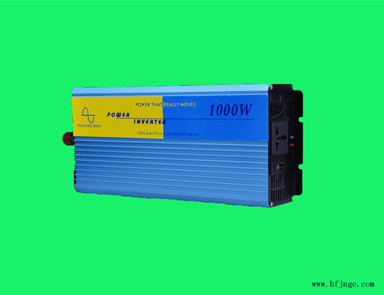
2)Technical parameters:
OUTPUT | OUTPUT VOLT | 100/110/120/220/230/240VAC
OUTPUT | CONTINUOUS POWER | 1000W
OUTPUT | SURGE POWER | 2000W
OUTPUT | WAVEFORM | PURE SINE WAVE
OUTPUT | FREQUENCY | 50Hz/60Hz
OUTPUT | AC REGULATION | low & high 10%
OUTPUT | USB CHARGER | 5V
OUTPUT | LED INDICATOR | LED DISPLAY POWER & FAIL STATUS
INPUT | NO LOAD CURRENT DRAW | 0.2A～0.3A | 0.15A～0.2A | 0.1A～0.15A
INPUT | DC VOLTAGE | 10-15VDC | 20-30VDC | 40-61VDC
INPUT | VOLTAGE RANGE | 12VDC | 24VDC | 48VDC
INPUT | FUSE | 35A | 20A | 15A
PROTECTION | BATTERY LOW SHUTDOWN | ±10V
PROTECTION | OVER TEMPERATURE | ±70℃
PROTECTION | BATTERY LOW ALARM | ±10.5V
PROTECTION | OUTPUT SHORT | SHUT OFF OUTPUT VOLTAGE,RE-POWER ON TO RECOVER
PROTECTION | OVER LOAD | 120%
PROTECTION | OVER VOLTAGE | ±15V | ±30V | ±61V
OTHER | DIMENSION(L*W*H) | 310*150*70mm
OTHER | INNER BOX DIMENSION | 390*190*110mm
OTHER | CARTON DIMENSION | 440*420*320mm
OTHER | NET WEIGHT | 3.5±0.2KG
OTHER | GROSS WEIGHT | 14.8±1KG
OTHER | PACKING | 4PCS/CTN
- AE-H1500 High frequency pure sine wave inverter
1) Product picture:
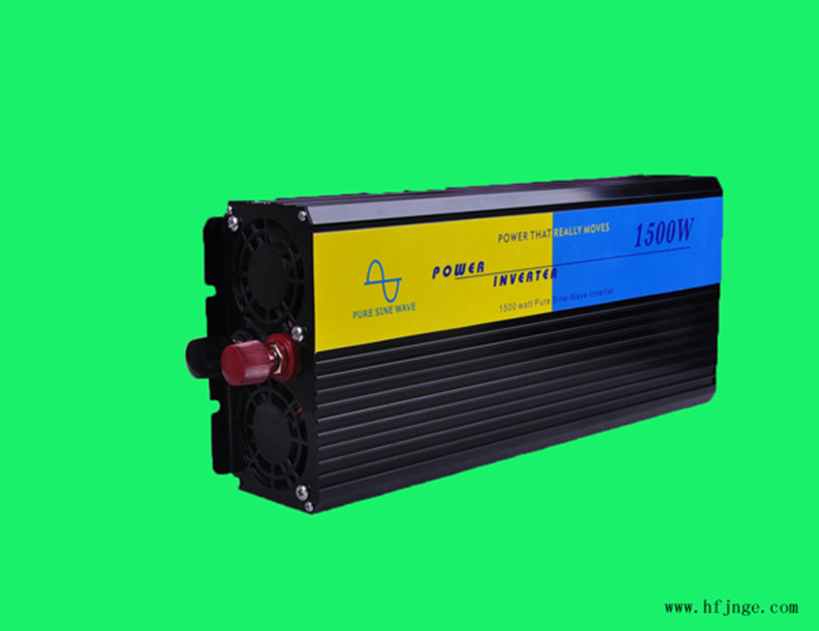
2)Technical parameters:
OUTPUT | OUTPUT VOLT | 100/110/120/220/230/240VAC
OUTPUT | CONTINUOUS POWER | 1500W
OUTPUT | SURGE POWER | 3000W
OUTPUT | WAVEFORM | PURE SINE WAVE
OUTPUT | FREQUENCY | 50Hz/60Hz
OUTPUT | AC REGULATION | low & high 10%
OUTPUT | USB CHARGER | 5V
OUTPUT | LED INDICATOR | LED DISPLAY POWER & FAIL STATUS
INPUT | NO LOAD CURRENT DRAW | 0.2A～0.3A | 0.15A～0.2A | 0.1A～0.15A
INPUT | DC VOLTAGE | 10-15VDC | 20-30VDC | 40-61VDC
INPUT | VOLTAGE RANGE | 12VDC | 24VDC | 48VDC
INPUT | FUSE | 35A | 20A | 15A
PROTECTION | BATTERY LOW SHUTDOWN | ±10V
PROTECTION | OVER TEMPERATURE | ±70℃
PROTECTION | BATTERY LOW ALARM | ±10.5V
PROTECTION | OUTPUT SHORT | SHUT OFF OUTPUT VOLTAGE,RE-POWER ON TO RECOVER
PROTECTION | OVER LOAD | 120%
PROTECTION | OVER VOLTAGE | ±15V | ±30V | ±61V
OTHER | DIMENSION(L*W*H) | 340*150*70mm
OTHER | INNER BOX DIMENSION | 455*190*110mm
OTHER | CARTON DIMENSION | 490*430*300mm
OTHER | NET WEIGHT | 4±0.5KG
OTHER | GROSS WEIGHT | 17.2±1KG
OTHER | PACKING | 4PCS/CTN
- AE-H2000 High frequency pure sine wave inverter
1) Product picture:
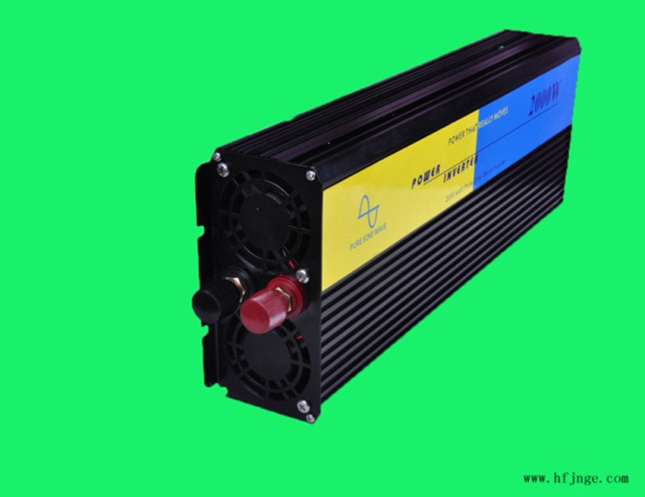
2)Technical parameters:
OUTPUT | OUTPUT VOLT | 100/110/120/220/230/240VAC
OUTPUT | CONTINUOUS POWER | 2000W
OUTPUT | SURGE POWER | 4000W
OUTPUT | WAVEFORM | PURE SINE WAVE
OUTPUT | FREQUENCY | 50Hz/60Hz
OUTPUT | AC REGULATION | low & high 10%
OUTPUT | USB CHARGER | 5V
OUTPUT | LED INDICATOR | LED DISPLAY POWER & FAIL STATUS
INPUT | NO LOAD CURRENT DRAW | 0.2A～0.3A | 0.15A～0.2A | 0.1A～0.15A
INPUT | DC VOLTAGE | 10-15VDC | 20-30VDC | 40-61VDC
INPUT | VOLTAGE RANGE | 12VDC | 24VDC | 48VDC
INPUT | FUSE | 35A | 20A | 15A
PROTECTION | BATTERY LOW SHUTDOWN | ±10V
PROTECTION | OVER TEMPERATURE | ±70℃
PROTECTION | BATTERY LOW ALARM | ±10.5V
PROTECTION | OUTPUT SHORT | SHUT OFF OUTPUT VOLTAGE,RE-POWER ON TO RECOVER
PROTECTION | OVER LOAD | 120%
PROTECTION | OVER VOLTAGE | ±15V | ±30V | ±61V
OTHER | DIMENSION(L*W*H) | 395*150*70mm
OTHER | INNER BOX DIMENSION | 510*190*110mm
OTHER | CARTON DIMENSION | 540*340*310mm
OTHER | NET WEIGHT | 5.5±0.5KG
OTHER | GROSS WEIGHT | 20±1KG
OTHER | PACKING | 4PCS/CTN
- AE-H2500 High frequency pure sine wave inverter
1) Product picture:
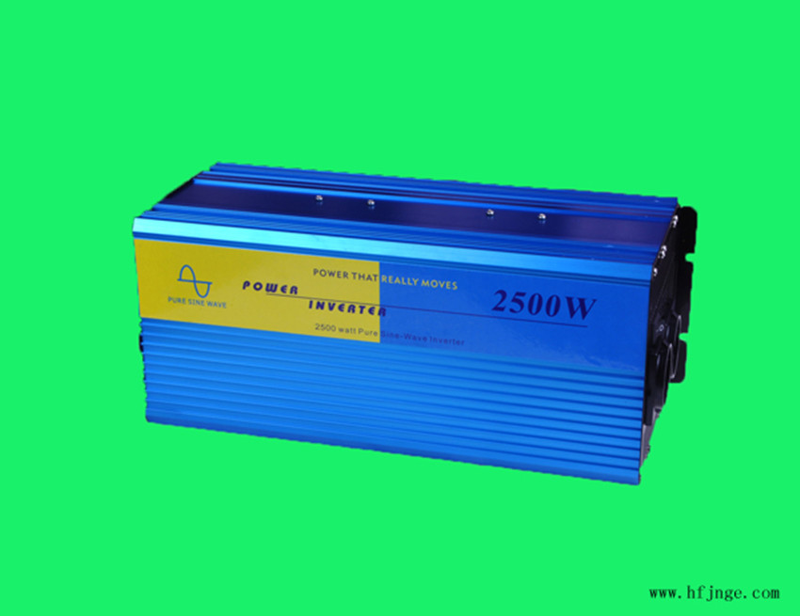
2)Technical parameters:
OUTPUT | OUTPUT VOLT | 100/110/120/220/230/240VAC
OUTPUT | CONTINUOUS POWER | 2500W
OUTPUT | SURGE POWER | 5000W
OUTPUT | WAVEFORM | PURE SINE WAVE
OUTPUT | FREQUENCY | 50Hz/60Hz
OUTPUT | AC REGULATION | low & high 10%
OUTPUT | USB CHARGER | 5V
OUTPUT | LED INDICATOR | LED DISPLAY POWER & FAIL STATUS
INPUT | NO LOAD CURRENT DRAW | 0.2A～0.3A | 0.15A～0.2A | 0.1A～0.15A
INPUT | DC VOLTAGE | 10-15VDC | 20-30VDC | 40-61VDC
INPUT | VOLTAGE RANGE | 12VDC | 24VDC | 48VDC
INPUT | FUSE | 35A | 20A | 15A
PROTECTION | BATTERY LOW SHUTDOWN | ±10V
PROTECTION | OVER TEMPERATURE | ±70℃
PROTECTION | BATTERY LOW ALARM | ±10.5V
PROTECTION | OUTPUT SHORT | SHUT OFF OUTPUT VOLTAGE,RE-POWER ON TO RECOVER
PROTECTION | OVER LOAD | 120%
PROTECTION | OVER VOLTAGE | ±15V | ±30V | ±61V
OTHER | DIMENSION(L*W*H) | 370*150*152mm
OTHER | INNER BOX DIMENSION | 530*190*190mm
OTHER | CARTON DIMENSION | 540*290*510mm
OTHER | NET WEIGHT | 7±0.5KG
OTHER | GROSS WEIGHT | 15±1KG
OTHER | PACKING | 2PCS/CTN
- AE-H3000 High frequency pure sine wave inverter
1) Product picture:
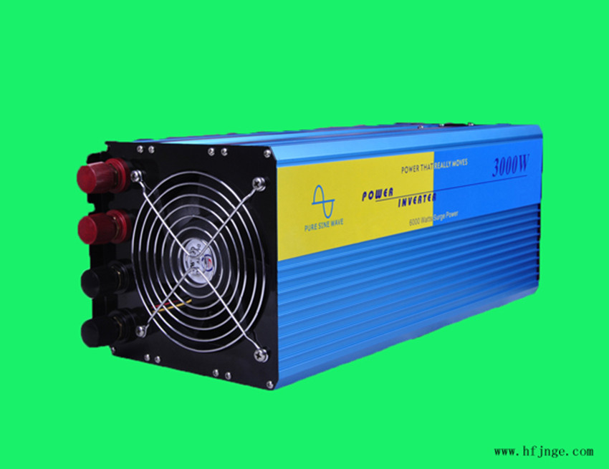
2)Technical parameters:
OUTPUT | OUTPUT VOLT | 100/110/120/220/230/240VAC
OUTPUT | CONTINUOUS POWER | 3000W
OUTPUT | SURGE POWER | 6000W
OUTPUT | WAVEFORM | PURE SINE WAVE
OUTPUT | FREQUENCY | 50Hz/60Hz
OUTPUT | AC REGULATION | low & high 10%
OUTPUT | USB CHARGER | 5V
OUTPUT | LED INDICATOR | LED DISPLAY POWER & FAIL STATUS
INPUT | NO LOAD CURRENT DRAW | 0.2A～0.3A | 0.15A～0.2A | 0.1A～0.15A
INPUT | DC VOLTAGE | 10-15VDC | 20-30VDC | 40-61VDC
INPUT | VOLTAGE RANGE | 12VDC | 24VDC | 48VDC
INPUT | FUSE | 35A | 20A | 15A
PROTECTION | BATTERY LOW SHUTDOWN | ±10V
PROTECTION | OVER TEMPERATURE | ±70℃
PROTECTION | BATTERY LOW ALARM | ±10.5V
PROTECTION | OUTPUT SHORT | SHUT OFF OUTPUT VOLTAGE,RE-POWER ON TO RECOVER
PROTECTION | OVER LOAD | 120%
PROTECTION | OVER VOLTAGE | ±15V | ±30V | ±61V
OTHER | DIMENSION(L*W*H) | 370*150*152mm
OTHER | INNER BOX DIMENSION | 530*190*190mm
OTHER | CARTON DIMENSION | 540*280*520mm
OTHER | NET WEIGHT | 7.5±0.5KG
OTHER | GROSS WEIGHT | 16±1KG
OTHER | PACKING | 2PCS/CTN
- AE-H4000 High frequency pure sine wave inverter
1) Product picture:
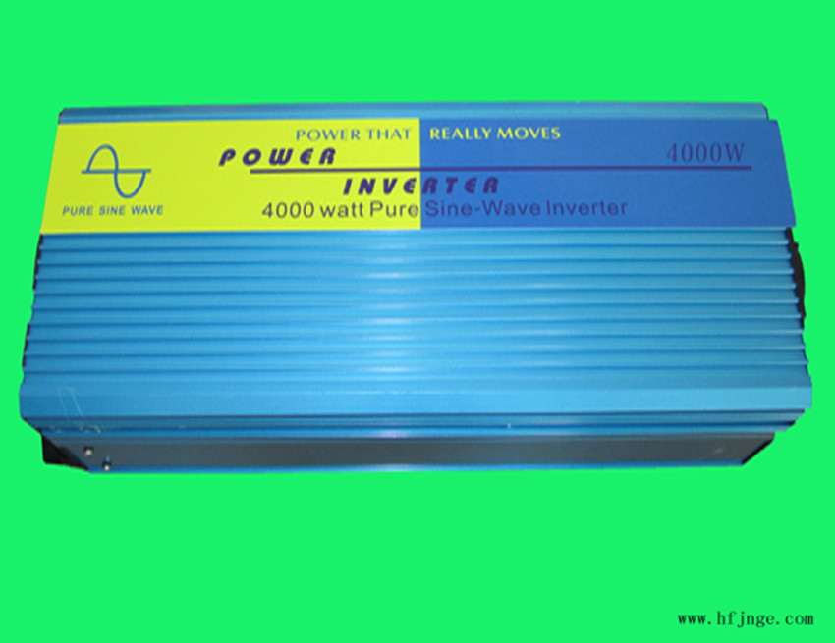
2)Technical parameters:
OUTPUT | OUTPUT VOLT | 100/110/120/220/230/240VAC
OUTPUT | CONTINUOUS POWER | 4000W
OUTPUT | SURGE POWER | 8000W
OUTPUT | WAVEFORM | PURE SINE WAVE
OUTPUT | FREQUENCY | 50Hz/60Hz
OUTPUT | AC REGULATION | low & high 10%
OUTPUT | USB CHARGER | 5V
OUTPUT | LED INDICATOR | LED DISPLAY POWER & FAIL STATUS
INPUT | NO LOAD CURRENT DRAW | 0.2A～0.3A | 0.15A～0.2A | 0.1A～0.15A
INPUT | DC VOLTAGE | 10-15VDC | 20-30VDC | 40-61VDC
INPUT | VOLTAGE RANGE | 12VDC | 24VDC | 48VDC
INPUT | FUSE | 35A | 20A | 15A
PROTECTION | BATTERY LOW SHUTDOWN | ±10V
PROTECTION | OVER TEMPERATURE | ±70℃
PROTECTION | BATTERY LOW ALARM | ±10.5V
PROTECTION | OUTPUT SHORT | SHUT OFF OUTPUT VOLTAGE,RE-POWER ON TO RECOVER
PROTECTION | OVER LOAD | 120%
PROTECTION | OVER VOLTAGE | ±15V | ±30V | ±61V
OTHER | DIMENSION(L*W*H) | 370*150*152mm
OTHER | INNER BOX DIMENSION | 530*190*190mm
OTHER | CARTON DIMENSION | 540*280*520mm
OTHER | NET WEIGHT | 7.5±0.5KG
OTHER | GROSS WEIGHT | 16±1KG
OTHER | PACKING | 2PCS/CTN
- AE-H5000 High frequency pure sine wave inverter
1) Product picture:
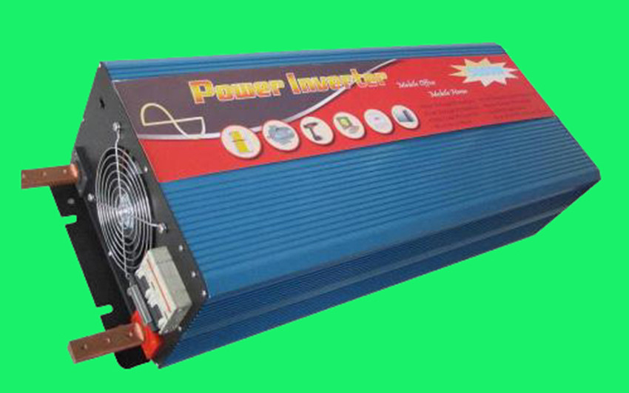
2)Technical parameters:
OUTPUT | OUTPUT VOLT | 100/110/120/220/230/240VAC
OUTPUT | CONTINUOUS POWER | 5000W
OUTPUT | SURGE POWER | 10000W
OUTPUT | WAVEFORM | PURE SINE WAVE
OUTPUT | FREQUENCY | 50Hz/60Hz
OUTPUT | AC REGULATION | low & high 10%
OUTPUT | USB CHARGER | 5V
OUTPUT | LED INDICATOR | LED DISPLAY POWER & FAIL STATUS
INPUT | NO LOAD CURRENT DRAW | 0.2A～0.3A | 0.15A～0.2A | 0.1A～0.15A
INPUT | DC VOLTAGE | 10-15VDC | 20-30VDC | 40-61VDC
INPUT | VOLTAGE RANGE | 12VDC | 24VDC | 48VDC
INPUT | FUSE | 35A | 20A | 15A
PROTECTION | BATTERY LOW SHUTDOWN | ±10V
PROTECTION | OVER TEMPERATURE | ±70℃
PROTECTION | BATTERY LOW ALARM | ±10.5V
PROTECTION | OUTPUT SHORT | SHUT OFF OUTPUT VOLTAGE,RE-POWER ON TO RECOVER
PROTECTION | OVER LOAD | 120%
PROTECTION | OVER VOLTAGE | ±15V | ±30V | ±61V
OTHER | DIMENSION(L*W*H) | 560*240*150mm
OTHER | INNER BOX DIMENSION | 720*335*235mm
OTHER | CARTON DIMENSION | 730*355*265mm
OTHER | NET WEIGHT | 15±0.2KG
OTHER | GROSS WEIGHT | 16±1KG
OTHER | PACKING | 1PCS/CTN
- AE-H6000 High frequency pure sine wave inverter
1) Product picture:
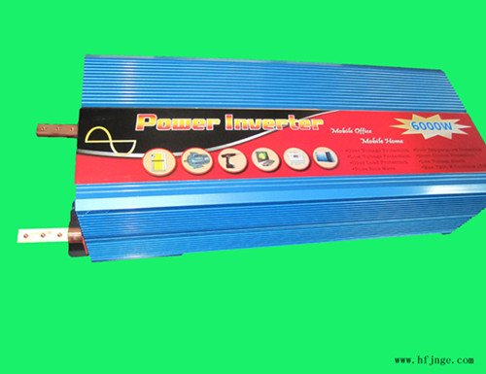
2)Technical parameters:
OUTPUT | OUTPUT VOLT | 100/110/120/220/230/240VAC
OUTPUT | CONTINUOUS POWER | 6000W
OUTPUT | SURGE POWER | 12000W
OUTPUT | WAVEFORM | PURE SINE WAVE
OUTPUT | FREQUENCY | 50Hz/60Hz
OUTPUT | AC REGULATION | low & high 10%
OUTPUT | USB CHARGER | 5V
OUTPUT | LED INDICATOR | LED DISPLAY POWER & FAIL STATUS
INPUT | NO LOAD CURRENT DRAW | 0.2A～0.3A | 0.15A～0.2A | 0.1A～0.15A
INPUT | DC VOLTAGE | 10-15VDC | 20-30VDC | 40-61VDC
INPUT | VOLTAGE RANGE | 12VDC | 24VDC | 48VDC
INPUT | FUSE | 35A | 20A | 15A
PROTECTION | BATTERY LOW SHUTDOWN | ±10V
PROTECTION | OVER TEMPERATURE | ±70℃
PROTECTION | BATTERY LOW ALARM | ±10.5V
PROTECTION | OUTPUT SHORT | SHUT OFF OUTPUT VOLTAGE,RE-POWER ON TO RECOVER
PROTECTION | OVER LOAD | 120%
PROTECTION | OVER VOLTAGE | ±15V | ±30V | ±61V
OTHER | DIMENSION(L*W*H) | 560*240*150mm
OTHER | INNER BOX DIMENSION | 720*335*235mm
OTHER | CARTON DIMENSION | 730*355*265mm
OTHER | NET WEIGHT | 15±0.2KG
OTHER | GROSS WEIGHT | 16±1KG
OTHER | PACKING | 1PCS/CTN

Address and contract ：
Address: Room 602, Building A Anhui Circular Economy Technology academy of Engineering,
Changjiang West Road 2221, Hefei ,Anhui,China
Tel：
Fax：
Post code：
E-mail: atone@atoneenergy.com
Website：www.atoneenergy.com

