MP11 series ups （1k－20k）
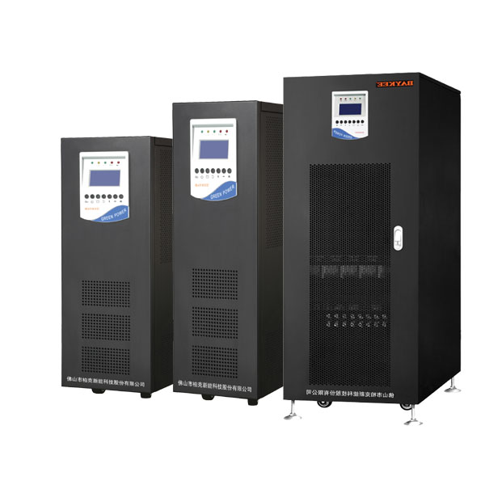

Pure sine wave output, true on-line double conversion design.

Adopt 4 layers PCB, and SMD technology.

With the sixth generation IGBT, the working efficiency of inverter much higher and the heat dissipation better, more reliable.

User-friendly operation and visual parameter, optional language and logo.

Set the work mode on the touch screen directly, UPS mode ECO mode EPS mode.

Provides intelligent detection for whole process. All power’s supply working status, breaker status, and all circuits working status.

It is completely able to load from 0-100% while no need to change to bypass, which make sure the output reliable.

Cold start.

Generator compatible.

With RS232 and RS485 standard interface, optional SNMP and dry contact connection.

Intelligent Battery Management
MP11 series UPS own intelligent Battery Management, it can adjust battery charging parameter according to the user's battery configuration, and it can do the equalized charging and float charging conversion, temperature compensation charging and discharge management. Besides, MP11 series UPS can detect the battery running status through monitoring interface, makes the battery running efficiency higher. Intelligent battery management not only reduces the administrator's burden, but also prolongs the battery life more than 55%.
Intelligent detection system full process protection
The system's MCU uninterruptedly on-line detect all power status, circuit breaker status and all circuit working status. When appear fault, the detection system immediately alarms and informs the administrator, and synchronous start UPS overall protection function.
Intelligent communication tool remote monitoring
RS232 and RS484 communication port really come true multipurpose communication and remote monitoring
Optional SNMP card can come true remote monitoring and network management, Optional dry contact effectively realized the status monitoring for UPS through adopting passive contact.
Adopt high precision SMD technology, makes complete machine precision higher
MP11 series has changed the traditional plug-in circuit processing craft, all adopt high precision SMD technology, can save space and eliminate the traditional UPS circuit shortcomings, For safe running of integrated circuit, improving the reliability and operation precision.

MP11 series comprehensively adopt SMD technology, high temperature resistant, high accuracy, filtering performance is wonderful, the more stable performance, more durable, service life is increased by 80%.
Based on the sixth generation of IGBT and high-speed static switch over technology, the reliability is higher

IGBT has good high-speed switching characteristics, has high voltage and large current job characteristics, Use the voltage type drive, need small control power. The sixth generation IGBT has lower saturation pressure drop, inverter efficiency is higher, low temperature, higher reliability.
Adopt double conversion pure online design and high-speed static switch over technology, more stable performance.

Other features

Superior load characteristics

Completely satisfy from 0 to 100% load leap, without switching to bypass, and protect the output is stable and reliable.

Perfect protection function

There are many kinds of system protection and alarm function.
For example, the input/output over voltage protection, input surge protection, sequence protection, battery overcharge and overdischarge protection, overloading short circuit protection, high temperature protection and so on

High-performance dynamic characteristics

Adopt various feedback control, like instantaneous control mode and effective value etc., realized the high dynamic adjustment, reduce output voltage distortion degree.

Optional input harmonic filter

Effectively suppress harmonic pollution, improve the UPS input power factor, reduce input harmonic current

Optional battery circuit module
Single parameter can be set, and display in a display board, If any battery fault immediately alarm, and inform the administrator.
Personalized Settings

Users can set the UPS work status on the panel can according to electricity requirement, optional UPS work mode, ECO energy conservation work mode, EPS work mode

MP11 Series Technical Specification
Product Model |  | MP1101K |  | MP1102K |  | MP1103K |  | MP1104K |  | MP1106K |  | MP1108K |  | MP1110K |  | MP1115K | MP1120K
Nominal Capacity |  | 800W |  | 1600W |  | 2400W |  | 3200W |  | 4800W |  | 6400W |  | 8000W |  | 12000W | 16000W
Working Pattern |  | Power Frequency Double conversion Pure Sine Wave on-line
Phase |  | Single Phase(L+N+G)
Input Power factor |  | >0.85
Rectifier | Input Voltage | 220Vac; 230Vac; 240Vac
Rectifier | Range | ±25%
Rectifier | Input Frequency | 50Hz±10%; 60Hz±10%;
Rectifier | Input THD | <2%
Rectifier | Soft Start-up | 0～100% 5sec
Charge | Charge Mode | Before constant current to constant voltage, with temp compensation charge and even float charging conversion
Charge | Float Voltage | 55VDC |  |  |  |  |  | 220VDC
Charge | Temp. compensation | -3mV/( 1 pcs)
Charge | Charge Current | 5Amp-20Amp
Battery | Battery Type | Maintenance-free lead acid battery
Battery | Battery Capacity | 7～999AH settable ( auto-setting according to the capacity)
Battery | Battery Number | 4pcs /12V |  |  |  |  |  | 16pcs /12V
Inverter | Phase | Single phase
Inverter | Rated Capacity | Rated Capacity ×0.8
Inverter | Output Voltage | 220Vac; 230Vac; 240Vac
Inverter | Output Voltage Distortion | ±1 %( Stable load); ±5%( fluctuant load)
Inverter | Freq Distortion | 50Hz 60Hz<±0.5%(Out of Step)
Inverter | Crest Factor | >3:1
Inverter | Output THD | Sine wave ,linear load<3%;non-linear load<5%
Inverter | Dynamic Characteristic | Instant voltage<±5%(from 0 to100% ), Instant recover time<10MP11
Inverter | Imbalance Load Voltage | Output Voltage <±5%
Inverter | Overload Protection | 150% 1min; 200% 1S
Inverter | Efficiency | >93%(full load)
Bypass | Phase | Single Phase+N
Bypass | Voltage | 220Vac; 230Vac; 240Vac
Bypass | Transfer Time | <1 0MS( static switch with 0 S )
Protection | Input Protection | Input over/low voltage ;over frequency
Protection | Output Protection | Over current short circuit ; factor low
Protection | Battery Protection | Over charge ; over-discharge
Protection | Temp Protection | Environment over temp protection, inverter over temp protection
Protection | Hardware Failure | Assistant power abnormal, breaker cut off, breaker overload, power components over current/over voltage etc protection
Protection | Cooling | COMPULSIVE VENTILATION(with temperature control)
Protection | Communicate Port | RS232/ RS485; optional SNMP card(for internet)
Protection | Safety Level | IP21
Protection | Noise (dB) | 45～60
Protection | Size (W*D*H)mm | 210*520*530 |  |  |  |  | 220*520*640 |  |  |  | 220*500*760 |  |  |  | 450*600*1200
Protection | Weight(Kg) | 51 | 58 |  | 65 |  | 70 |  | 73 |  | 85 |  | 108 |  | 265 |  | 300

